**Climate moderates composition of plant-pollinator networks**

Manu E. Saunders1,2, Liam K. Kendall1,3, Jose B. Lanuza1, Romina Rader1, Mark A. Hall1,4, Jamie Stavert1

1Ecosystem Management, School of Environmental and Rural Science, University of New England, Armidale NSW 2351 Australia

2UNE Business School, University of New England, Armidale NSW 2351 Australia

3CSIRO Agriculture, GPO Box 2583, Brisbane, QLD 4001, Australia

4Hawkesbury Institute for the Environment, Western Sydney University, Richmond, NSW 2753, Australia

**Abstract**

Climate is thought to have a strong influence on pollinator community composition as insects are more sensitive to temperature extremes3 and have limited ability to regulate body temperature. Yet, we still know little about how climate drives composition of plant-pollinator interactions at global scales4. We analysed 184 plant-pollinator networks from the world’s five major climate zones to evaluate the extent to which climate drives the relative proportion of flower-visiting insects in pollination networks. Our global analysis revealed that pollinator generalism5 (i.e how many different plants pollinators visit) varies across climate zones. Non-syrphid Diptera had the greatest proportion of links in polar climates, while bees and syrphid flies dominated networks in the continental zone. Climate zone was a more powerful predictor of proportional and absolute pollinator generalism than latitude6. Our analyses provide substantial advances in knowledge of how response diversity influences community composition at the global scale, and supports the need for greater research effort to understand the vulnerability of plant-pollinator interactions to global environmental change.

**Main**

As insects are broadly ectothermic, the activity of flower visiting insects generally increases as ambient temperature rises, and warmer flowers may attract more pollinators7,8. Yet, thermal tolerance varies across taxonomic groups, meaning that climatic conditions are likely to influence the composition of insect pollinator communities across space and time. For example, dipterans are generally thought to be more cold-tolerant than other flying insects and have been recorded as the most common flower visitors at cooler temperatures, especially in some arctic and alpine plant-pollinator networks9,10,11. Bees are most abundant and diverse in warm arid regions12, and are generally less active during winter and in cold, inclement weather. These varying responses among taxa provides response diversity which buffers ecosystem service delivery and function across space and time13,14. While it is evident that diversity is critical to maintain service delivery over broad spatial scales (Winfree), evidence of how local response diversity scales up to general biogeographic patterns in plant-pollinator networks is lacking.

Historically, plant-pollinator network studies have largely been localised, descriptive and focused on documenting diversity and interactions15. The small number of studies that have identified ~~effects~~ how global drivers, such as climate, might alter plant-pollinator networks, have been largely speculative, based on simulated data, or from local or regional systems16,17. Broad

Analyses investigating global patterns in plant-pollinator networks have focused on broad patterns in network metrics and species richness, with limited discussion of taxonomic identity or community composition18–20. Where biogeographical gradients have been considered, the focus has traditionally been on testing the effects of latitude on network interactions21,22. However, latitude is a poor proxy for the environmental nuances that drive community-level interactions, and the historical focus on latitude has limited our understanding of global-scale patterns of ecosystem function6. Here we provide the first empirical evidence that climate zone moderates the relative proportion of flower species that different insect taxa visit and generalism of floral visitors.

We searched the peer-reviewed literature and research theses published online and collated 184 community networks linking flowering plants to insect pollinators or flower visitors (i.e. plant-pollinator networks, see Methods).

At the global scale, we found that Köppen climate zone drives compositional dissimilarities between plant-pollinator interactions (PERMANOVA, F(4,179) = 63.23; *R2* = 0.59; *P* < 0.001; Fig. 1). In particular, the composition of interactions in tropical and arid zone plant-pollinator networks are distinct from each other and from all other climate zones (SI: Table S1). The composition of interactions in temperate zone plant-pollinator networks is strongly dissimilar from polar zone networks, while networks in the continental climate zone are weakly dissimilar from those in temperate and polar climate zones. Dispersion of plant-pollinator interaction composition is similar across all climate zones (all pairwise Tukey’s HSD *P* > 0.05).

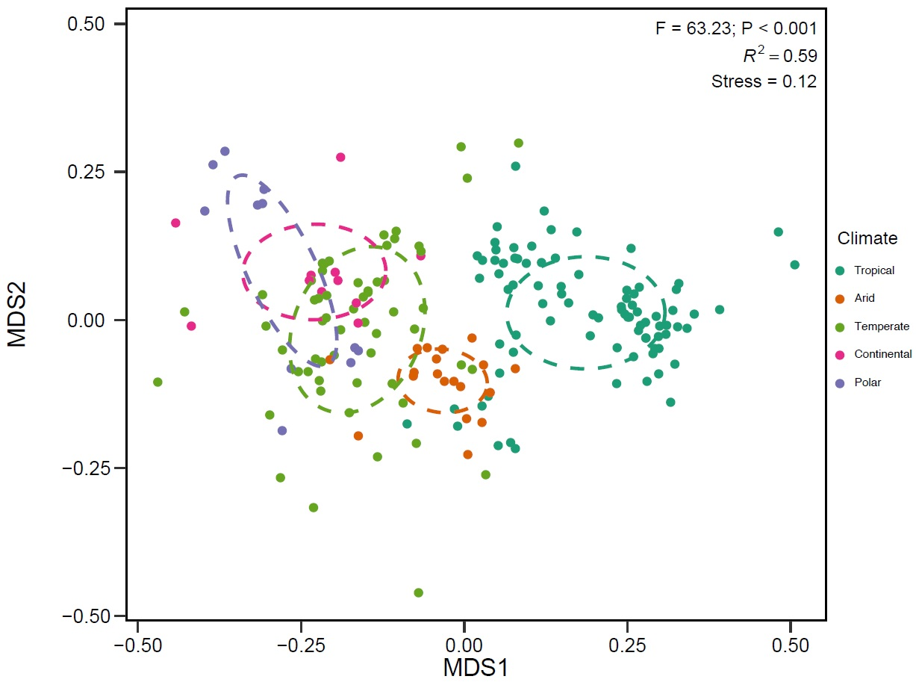

**Figure 1.** NMDS ordination of plant-pollinator interaction composition in each climate zone. Each point represents one plant pollinator network and dashed circles represent confidence ellipses for the mean (group centroid) of each climate zone.

We found that one dipteran family (Syrphidae) and one hymenopteran family (Apidae) comprised over one-quarter (28%) of total links across all networks (Table 1). To explore taxonomic differences in pollinator generalism (i.e. absolute and proportional ecological generalism5) across climate zones, we used Bayesian generalised linear mixed effects models (see Methods) and grouped pollinator species by functional groupings that reflect key pollinator taxa: Syrphidae, non-syrphid Diptera, Bees, non-bee Hymenoptera, Lepidoptera, Coleoptera. We accounted for variation among networks by including an offset term in the absolute generalism model (log-transformed total number of plant-pollinator links within each network), and a random effect of “network” nested within “study” in both models, to account for the dependent data structure of multiple networks within studies. The interaction between ‘pollinator taxa : climate zone’ was the best predictor for pollinator generalism (Bayesian *R2*: 0.265~~, ΔWAIC: -592.62~~).

**Table 1: Top ten pollinator families with the greatest proportion of total links (*N* = 44,468) across all networks. See S1 Data for full list.**

|  |  |
| --- | --- |
| **Family** | **Proportion of total links** |
| Syrphidae | 0.142 |
| Apidae | 0.134 |
| Halictidae | 0.074 |
| Tachinidae | 0.045 |
| Andrenidae | 0.039 |
| Megachilidae | 0.037 |
| Muscidae | 0.037 |
| Bombyliidae | 0.022 |
| Crabronidae | 0.022 |
| Vespidae | 0.021 |

Relative to other pollinator taxa, bees had the greatest proportion of links in tropical, temperate and continental climate zones (Fig. 2A). In the arid zone, non-bee Hymenoptera had similar levels of proportional generalism to bees. In the polar zone, non-syrphid Diptera had the highest level of proportional generalism (Fig. 2A). Across all climate zones, except polar, we found that bees showed greater absolute generalism (i.e. visited more plant partners) compared with other pollinator taxa (Fig. 2B). However, compared to other climate zones, bees visited more plant species in the tropical climate zone (Fig. 3). Syrphidae had the highest proportion of total links across all networks, and recorded the highest number of plant partners in polar zones, but did not show the highest proportional generalism in any climate zone (Fig. 2). We separated Syrphidae from other Diptera, because they are common and recognisable pollinators, were the most common fly visitors in our dataset, and because analysing all data at family level was not possible, due to the high number of zeros across most insect families. Therefore, this result is likely an artefact of our groupings, not an indication that Syrphidae are not important pollinators.



**Figure 2.** A) Model-estimated proportion of network links (proportional generalism) and (B) species-level absolute generalism for each pollinator taxonomic group, in each climate zone. Dots are posterior mean estimates and error bars denote ± 95% credible intervals. Predictions of pollinator generalism are constrained to equal network size (100 plant-pollinator links).

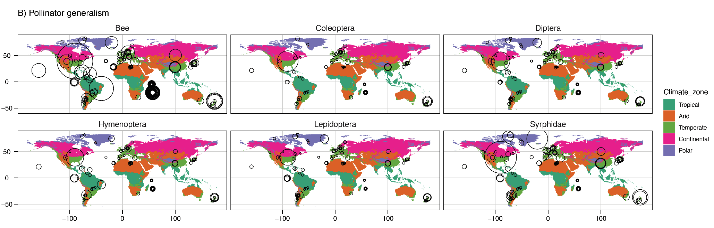

**Figure 3** Global map of absolute generalism for each pollinator taxonomic group within climate zones. Circles represent individual networks. Circle size is relative to the model estimates for pollinator generalism (number of plant partners) for each pollinator taxonomic group within each network. Predictions of pollinator generalism are constrained to equal network size (100 plant-pollinator links).

There are multiple ways to measure generalisation (cf. specialisation) in plant-pollinator networks5,23. We focused on comparing absolute and proportional ecological generalism, which are quantitative representations of network linkages. Our results highlight how focusing only on actual numbers of links in network studies overlooks important information about plant-pollinator communities. For example, Syrphidae had the highest number of plant partners in polar climates but had the greatest proportion of network links in continental climates (Fig. 2). Similarly, bees visited the most plant species in tropical zones, but had the greatest proportion of network links in continental zones (higher than Syrphidae). Non-syrphid Diptera had fewer plant partners, in absolute terms, across all networks; but, relative to other taxa and other climate zones, they were the most dominant pollinator in polar zones (Fig. 2). This shows that, for pollinators, actual number of plant species they are observed visiting is not necessarily indicative of their relative importance in the system.

Our results provide empirical evidence that non-syrphid flies are relatively more common as pollinators in polar zones, and bees are relatively more common as pollinators in continental and temperate climate zones. Our analysis is based on the most comprehensive set of insect pollinator networks collated thus far. Moreover, we separate insect pollinators into functional groupings to identify response diversity among taxa, whereas other studies have largely considered overall patterns for all pollinators, often grouping vertebrates and insects together. We also focus on relative proportions of observed pollinator taxa, rather than comparing network structure or diversity metrics, which can be influenced by sampling effort or network size. We have also shown that climate is a more powerful predictor of insect roles in plant-pollinator networks than latitude, despite latitude receiving much attention as a potential driver of plant-pollinator interactions6,21. We tested the effect of latitude on our data (see Methods), but both the proportion of network links and species-level generalism were better explained by the climate zone model than the latitude model (proportion of network links ΔWAIC: -47.71; species-level generalism ΔWAIC: -34.15). Furthermore, although previous work has discussed the influence of climate on plant-pollinator networks21, relationships were tested using temporal or annual temperature data only. Yet climate is a multivariate space encompassing more than just temperature fluctuations. Köppen climate zone classifications are extremely useful for aggregating complex climate gradients and vegetation patterns into simple, ecologically meaningful categories24. As we show here, climate zone is a more powerful predictor of insect community composition than proxy variables like latitude. We now require additional networks across underrepresented regions of the world to test whether the sub-categories of the Köppen classifications can better predict complex plant-pollinator interactions.

Climate change affects plant-pollinator networks through phenological mismatches, with potentially devastating effects on ecosystem function17. Understanding how composition of plant-pollinator networks varies across climate zones is a key first step to developing detailed analyses that identify how climate change affects species-level interactions at local and regional scales.

**Methods**

We collated 184 plant-pollinator networks from the Web of Life ecological networks database (<http://www.web-of-life.es/>), an exhaustive search of published journal articles, data repositories, and theses, and by directly contacting researchers. Although it is likely we have missed some networks, we are confident our analysis is more comprehensive than previous global network analyses, because we cover all climate zones and sourced new networks that have not been included in previous studies. We only used insect pollinator networks that recorded multiple taxonomic orders and thus did not focus on a single order or taxonomic group. We used the *taxize* package (v.0.9.5) to identify both plant and insect families and orders from provided datasets (Chamberlain & Szocs 2013; Chamberlain et al. 2019). All networks were analysed as binary networks, to address differences in sampling methods and effort among networks. We identified the Köppen climate zone for each network based on the spatial coordinates provided with each dataset using the *kgc* package (v1.0.0.2) (Bryant et al. 2017). All data, code and analyses are available at <https://github.com/JoseBSL/Geonet>.

We tested whether the composition of plant-pollinator interactions varied among climate zones by calculating pairwise Raup-Crick dissimilarity25 between networks using the *vegan* package (v.2.5-3)26. To account for varying network sizes, we computed the Raup-Crick dissimilarity using a null model, repeated for 999 iterations. Then, we assessed differences in the composition of plant-pollinator interactions among climate zones using a permutational analysis of variance (PERMANOVA)27. We evaluated dispersion of network dissimilarity values among climate zones with a permutational test of multivariate homogeneity of group dispersion (PERMDISP) and post-hoc pairwise Tukey’s Honest-Significant Difference (HSD) tests. We computed pairwise differences in the composition of plant-pollinator interactions between each climate zone using a pairwise PERMANOVA28. To account for multiple comparisons, *P*-values were adjusted using the false discovery rate (FDR) method29. Finally, we visualised differences in plant-pollinator interactions among networks in two-dimensional space with non-metric multidimensional scaling (NMDS) ordination.

To test whether climate zone influenced how pollinator taxonomic groups interacted within their networks, we focused on the following functional groupings: bees, non-bee Hymenoptera, Coleoptera, Lepidoptera, non-Syrphid Diptera, and Syrphidae. We separated bees from non-bee Hymenoptera, and syrphid flies (Syrphidae) from non-syrphid Diptera, because bees and syrphid flies are the most commonly-recorded pollinator taxa from their respective orders. We focus on two aspects of ecological generalism: proportional generalism and absolute generalism. Proportional generalism is the proportion of links to different plant species for each pollinator taxonomic group; we calculated this as the sum of unique links within each pollinator taxonomic group, divided by the total sum of unique links within each network. We defined absolute generalism of a pollinator as the number of links between each pollinator species to different plant species within a network. To estimate the proportional generalism (i.e., relative proportion of links) and absolute generalism (i.e., number of links per species) for each pollinator group within each climate zone, we specified Bayesian generalised linear mixed effects models using the *brms* package (version 2.5.0)30. These models were fit with beta and negative binomial distributions respectively. In each model, the response variable was the proportion of links for each pollinator taxonomic group or the number of species links within each network. Fixed effects were “pollinator taxa” (categorical), “climate zone” (categorical) and the two-way “pollinator order” : “climate zone” interaction. To account for differences in network size in the species generalism model (absolute generalism), we included an offset term of the log-transformed total number of plant-pollinator links within each network. In both models, we included a random effect of “network” nested within “study” to account for the dependent data structure of multiple networks within studies. We re-iterated each model with absolute latitude in interaction with pollinator taxa instead of climate zone and compare their predictive power using the widely applicable information criterion (WAIC). Pairwise differences between climates and pollinator group for either proportion of network links or pollinator species generalism were considered significant when the 95% highest density intervals did not overlap zero (see Supplementary Information, Table SX)31. We set weakly informative priors and manipulated Δ and maximum tree depth to reduce divergent transitions. We undertook posterior predictive checks visually using *bayesplot* (v1.6.0)32 and *Shinystan* (v.2.5.0)33. All data analyses were undertaken in R (v.3.5.1, R Core Team 2018).

**Author Contributions**

MES conceived the idea and led the study; LK, JB and JS collated datasets, wrote the code and conducted the analysis; all authors contributed to study design and manuscript preparation.

**Acknowledgements**

Thank you to all authors who published network matrices openly online, or sent us matrices upon our request. MES and JS are supported by individual UNE Postdoctoral Fellowships; RR is supported by ARC DExxxxx; ….

LKK is supported by an Ian Potter Foundation PhD scholarship grant and a CSIRO PhD top-up scholarship.

**Data availability**

All data, code and analyses are available at <https://github.com/JoseBSL/Geonet>.

1. Potts, S. G. *et al.* Global pollinator declines: trends, impacts and drivers. *Trends Ecol. Evol.* **25**, 345–353 (2010).

2. Rader, R., Bartomeus, I., Tylianakis, J. M. & Laliberté, E. The winners and losers of land use intensification: pollinator community disassembly is non-random and alters functional diversity. *Divers. Distrib.* **20**, 908–917 (2014).

3. Bale, J. S. & Hayward, S. A. L. Insect overwintering in a changing climate. *J. Exp. Biol.* **213**, 980–994 (2010).

4. Petanidou, T. *et al.* Climate drives plant-pollinator interactions even along small-scale climate gradients: the case of the Aegean. *Plant Biol.* **20 Suppl 1**, 176–183 (2018).

5. Armbruster, W. S. The specialization continuum in pollination systems: diversity of concepts and implications for ecology, evolution and conservation. *Funct. Ecol.* **31**, 88–100 (2017).

6. Moles, A. T. & Ollerton, J. Is the notion that species interactions are stronger and more specialized in the tropics a zombie idea? *Biotropica* **48**, 141–145 (2016).

7. Rands, S. A. & Whitney, H. M. Floral Temperature and Optimal Foraging: Is Heat a Feasible Floral Reward for Pollinators? *PLOS ONE* **3**, e2007 (2008).

8. Sapir, Y., Shmida, A. & Ne’eman, G. Morning floral heat as a reward to the pollinators of the Oncocyclus irises. *Oecologia* **147**, 53–59 (2006).

9. Tiusanen, M., Hebert, P. D. N., Schmidt, N. M. & Roslin, T. One fly to rule them all-muscid flies are the key pollinators in the Arctic. *Proc. Biol. Sci.* **283**, (2016).

10. Elberling, H. & Olesen, J. M. The structure of a high latitude plant-flower visitor system: the dominance of flies. *Ecography* **22**, 314–323 (1999).

11. González, A. M. M. *et al.* Effects of climate on pollination networks in the West Indies. *J. Trop. Ecol.* **25**, 493–506 (2009).

12. Michener, C. D. Biogeography of the Bees. *Ann. Mo. Bot. Gard.* **66**, 277–347 (1979).

13. Rader, R., Reilly, J., Bartomeus, I. & Winfree, R. Native bees buffer the negative impact of climate warming on honey bee pollination of watermelon crops. *Glob. Change Biol.* **19**, 3103–3110 (2013).

14. Bartomeus, I. *et al.* Biodiversity ensures plant-pollinator phenological synchrony against climate change. *Ecol. Lett.* **16**, 1331–1338 (2013).

15. Knight, T. M. *et al.* Reflections on, and visions for, the changing field of pollination ecology. *Ecol. Lett.* **21**, 1282–1295 (2018).

16. Memmott, J., Craze, P. G., Waser, N. M. & Price, M. V. Global warming and the disruption of plant-pollinator interactions. *Ecol. Lett.* **10**, 710–717 (2007).

17. Hegland, S. J., Nielsen, A., Lázaro, A., Bjerknes, A.-L. & Totland, Ø. How does climate warming affect plant-pollinator interactions? *Ecol. Lett.* **12**, 184–195 (2009).

18. Traveset, A. *et al.* Global patterns of mainland and insular pollination networks. *Glob. Ecol. Biogeogr.* **25**, 880–890 (2016).

19. Olesen, J. M. & Jordano, P. GEOGRAPHIC PATTERNS IN PLANT–POLLINATOR MUTUALISTIC NETWORKS. *Ecology* (2002).

20. Trøjelsgaard, K. & Olesen, J. M. Macroecology of pollination networks. *Glob. Ecol. Biogeogr.* **22**, 149–162 (2013).

21. Schleuning, M. *et al.* Specialization of mutualistic interaction networks decreases toward tropical latitudes. *Curr. Biol.* **22**, 1925–1931 (2012).

22. Ollerton, J. & Cranmer, L. Latitudinal trends in plant-pollinator interactions: are tropical plants more specialised? *Oikos* **98**, 340–350 (2002).

23. Dormann, C. How to be a specialist? Quantifying specialisation in pollination networks. *Netw. Biol.* (2011).

24. Beck, H. E. *et al.* Present and future Köppen-Geiger climate classification maps at 1-km resolution. *Sci. Data* **5**, 180214 (2018).

25. Anderson, M. J. *et al.* Navigating the multiple meanings of β diversity: a roadmap for the practicing ecologist. *Ecol. Lett.* **14**, 19–28 (2011).

26. Oksanen, J. Multivariate Analysis of Ecological Communities in R: vegan tutorial. 43

27. Anderson, M. J. A new method for non-parametric multivariate analysis of variance. *Austral Ecol.* **26**, 32–46 (2001).

28. pairwise_adonis: Pairwise multilevel comparison using adonis in gauravsk/ranacapa: Utility Functions and ‘shiny’ App for Simple Environmental DNA Visualizations and Analyses. Available at: https://rdrr.io/github/gauravsk/ranacapa/man/pairwise_adonis.html. (Accessed: 25th January 2019)

29. Benjamini, Y. & Hochberg, Y. Controlling the False Discovery Rate: A Practical and Powerful Approach to Multiple Testing. *J. R. Stat. Soc. Ser. B Methodol.* **57**, 289–300 (1995).

30. Bürkner, P.-C. **brms** : An *R* Package for Bayesian Multilevel Models Using *Stan*. *J. Stat. Softw.* **80**, (2017).

31. Kruschke, J. *Doing Bayesian Data Analysis: A Tutorial with R, JAGS, and Stan*. (Academic Press, 2014).

32. Gabry, J. & Mahr, T. bayesplot: Plotting for Bayesian models. *R Package Version* **1**, (2017).

33. Gabry, J. *shinystan: Interactive visual and numerical diagnostics and posterior analysis for bayesian models [Computer software manual]*. (2016).